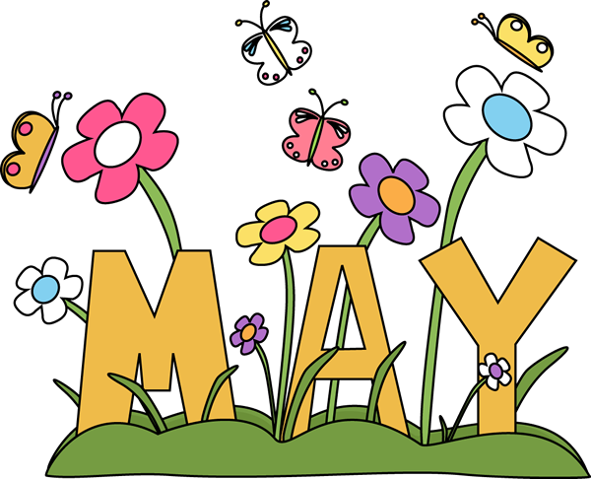

Mrs. Rogge’s May/June Snack Calendar
- If you would like to read to the class in honor of your scholar’s summer birthday you may do so on their assigned snack day. Please let Mrs. Rogge know at least 1 week in advance.
- Please remember to send healthy snack options! Thanks!
- Please send enough pre-portioned snacks & spoons (if necessary) for 20 scholars. Thank you!
Sunday | Monday | Tuesday | Wednesday | Thursday | Friday | Saturday
28 | 29  Ella | 30  Gretchen | May 1  Davis | 2  Happy B-day  Amira | 3  Virtue Assembly  9:15-9:45  Gabriel | 4
5 | 6  Vinny | 7  Fun Run  Hattie | 8  Elisa | 9  Grace  *Summer Birthday | 10  MN Zoo  Field Trip  Leo | 11
12 | 13  Ben | 14  Calista | 15  Vera | 16  Louis  *Summer Birthday | 17  Grandparent’s Day  (9:00-9:35)  Gus | 18
19 | 20  Addy | 21  William | 22  Keagan | 23  Happy B-day  Huck | 24  Heritage Feast (1:45-2:45)  Vinny | 25  Happy B-day  Vinny!
26 | 27  No School  (Memorial Day) | 28  Zana | 29  Ella | 30  Gretchen | 31  Davis  *Summer Birthday | 1
2 | 3  Virtue Assembly  @ 3:00pm  Amira | 4  Gabriel | 5  Vinny | 6  Recitation Celebration  1:45-2:45  Hattie | 7  Last Day  of Kindergarten!  Elisa | 8

